ECA0901 – DIGITAL SIGNAL PROCESSING

C01 – AT3 SIMULATION EXPERIMENT – 4
Design and Comparative Analysis of Butterworth, Chebyshev and Elliptic IIR Filters Using MATLAB
MATLAB CODE:

clc; clear; close all;
% Design stable IIR filter
[b,a] = butter(4,0.3,'low');
x = [1 zeros(1,49)];
% 1. Direct Form-I
y1 = filter(b,a,x);
% 2. Direct Form-II
y2 = filter(b,a,x);
% 3. Cascade realization
[sos,g] = tf2sos(b,a);
y3 = g*x;
for i = 1:size(sos,1)
y3 = filter(sos(i,1:3),sos(i,4:6),y3);
end
% 4. Parallel realization
[r,p,k] = residuez(b,a);
[br,ar] = residuez(r,p,k);
y4 = filter(br,ar,x);
% Display coefficients
disp('Numerator:'); disp(b);
disp('Denominator:'); disp(a);
disp('Second-Order Sections:'); disp(sos);
disp('Parallel Residues:'); disp(r);
disp('Parallel Poles:'); disp(p);
% 5. Compare responses
figure;
plot(0:49,y1,'b',0:49,y2,'r--',...
0:49,y3,'g:',0:49,y4,'k-.');
grid on;
xlabel('Samples'); ylabel('Amplitude');
title('IIR Realization Comparison');
legend('Direct Form-I','Direct Form-II','Cascade','Parallel');
fprintf('DF-I vs DF-II error = %.2e\n',max(abs(y1-y2)));
fprintf('DF-I vs Cascade error = %.2e\n',max(abs(y1-y3)));
fprintf('DF-I vs Parallel error = %.2e\n',max(abs(y1-y4)));OUTPUT:

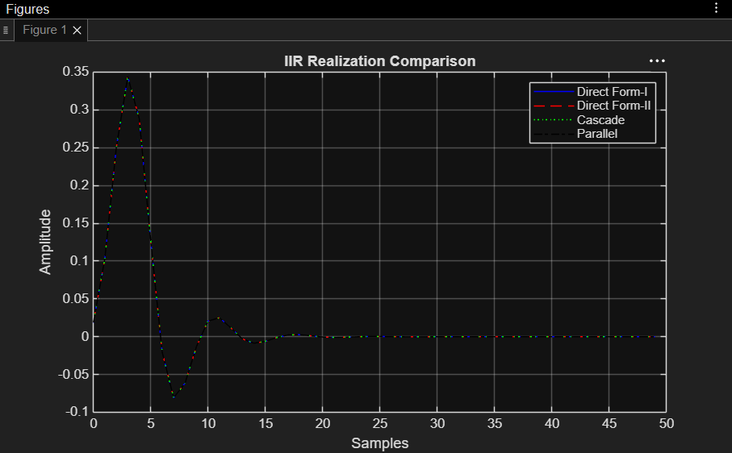

OUTPUT PARAMETERS:
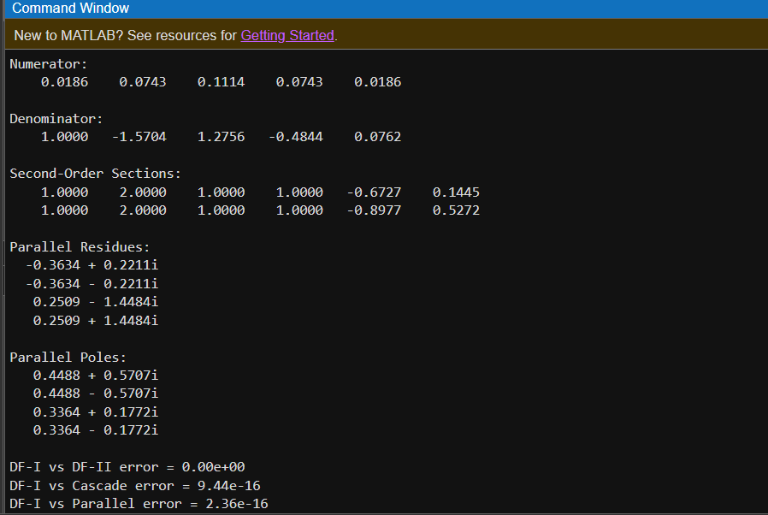

RESULT:
Thus, the IIR filter was realized using Direct Form-I, Direct Form-II, Cascade, and Parallel structures in MATLAB, and their output responses were verified.

